Module details

CS2701 Level 2 Group Project

Lab Sheet for Week 26 2025/26

Lab Title | Front-end and Back-end Integration
Front-end Technology | HTML, CSS, and JavaScript OR React
Lab Coordinator | Dr Nadine Aburumman

Aims of the Lab Session
In this lab session, you will develop and test a simple full-stack application using Spring Boot, Spring Data, and React OR (HTML, CSS, and JavaScript). Throughout this lab, you will do the following tasks:
- Connect a front-end to a Spring Boot backend using HTTP requests.
- Store data submitted from the React front-end through an API endpoint in an H2 database using Spring Data.

Learning Outcomes
This lab is related to some aspects of the following learning outcomes for the module:
LO2: Take an open-ended problem, collect and analyse relevant information and define and refine the requirements.
LO3: Independently and systematically design, develop and test a piece of software that is data-driven and has non-trivial functionality.
LO4: Compare and evaluate alternative problem solutions according to the given criteria, including from a technical perspective.
Preparation: Synchronise with CS2701-Resources repository
Synchronise your forked repo in GitHub to get the changes and the new starter files for this week’s lab. Then, pull the new changes to your Visual Studio Code environment.

https://github.com/NABBrunel/CS2701_Resources
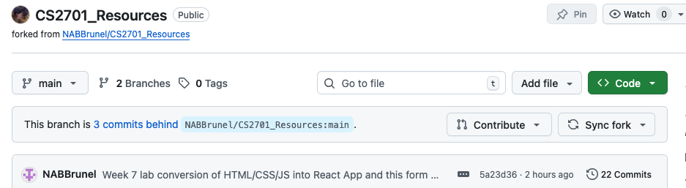
Figure 1. On GitHub, navigate to the main page of the forked repository that you want to sync with the upstream repository. Above the list of files, select the Sync fork dropdown menu.

Activity 1: Connecting the Allotment Food-Sharing Spring Boot Back-end to the HTML, CSS and JavaScript Front-end (Inside the Activity 1 Folder)

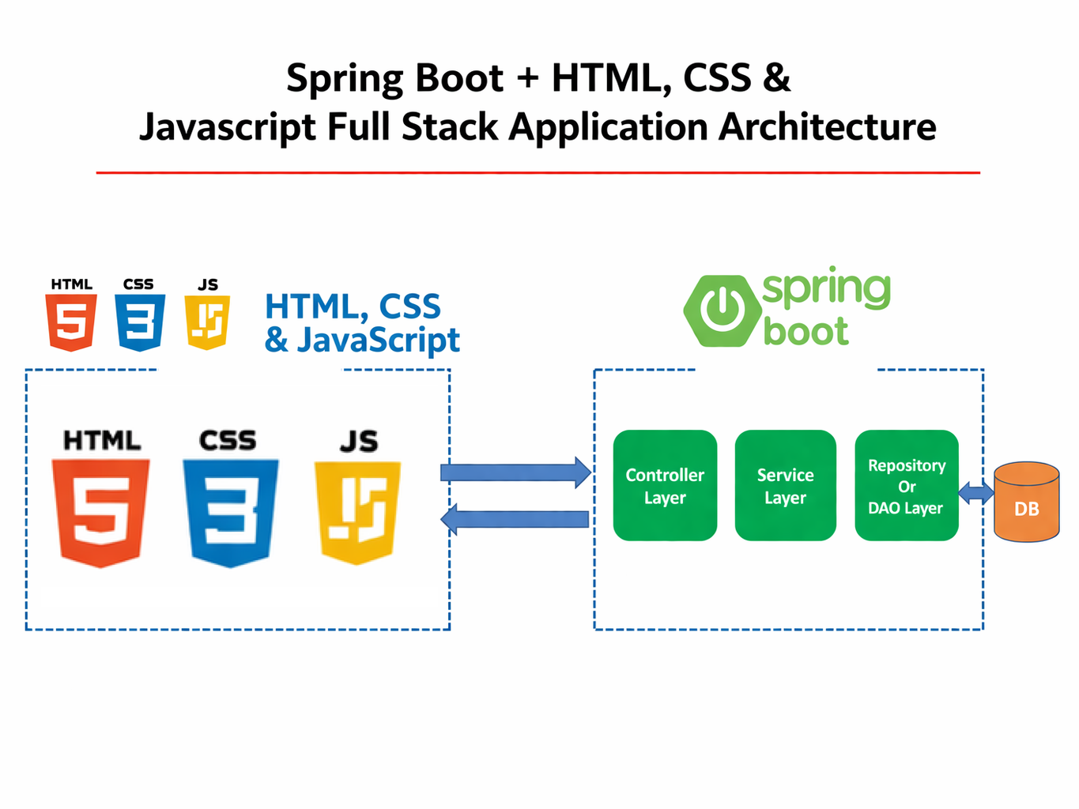
Figure 1. Full-stack application architecture showing a front-end built with HTML, CSS, and JavaScript communicating with a Spring Boot back-end and database.

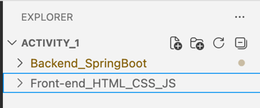
Step 1: Explore the structure of your project workspace, which contains two main folders: a Spring Boot back-end and a front-end built with HTML, CSS, and JavaScript.

Step 2: Navigate through the backend structure by expanding Backend_SpringBoot > src > main > java > com.example.demo, and observe the key packages such as Controllers, DTO, Exceptions, Models, Repos, and Services, along with the main application files.

Step 3: Add a CORS configuration bean to the DemoApplication.java class to enable communication between the front-end and back-end. Add the below code inside DemoApplication.java. Otherwise, browsers block such requests by default due to Cross-Origin Resource Sharing (CORS) policies. This bean explicitly allows your front-end to send requests (get, post, etc.) To the back-end, ensuring your application works correctly during development.

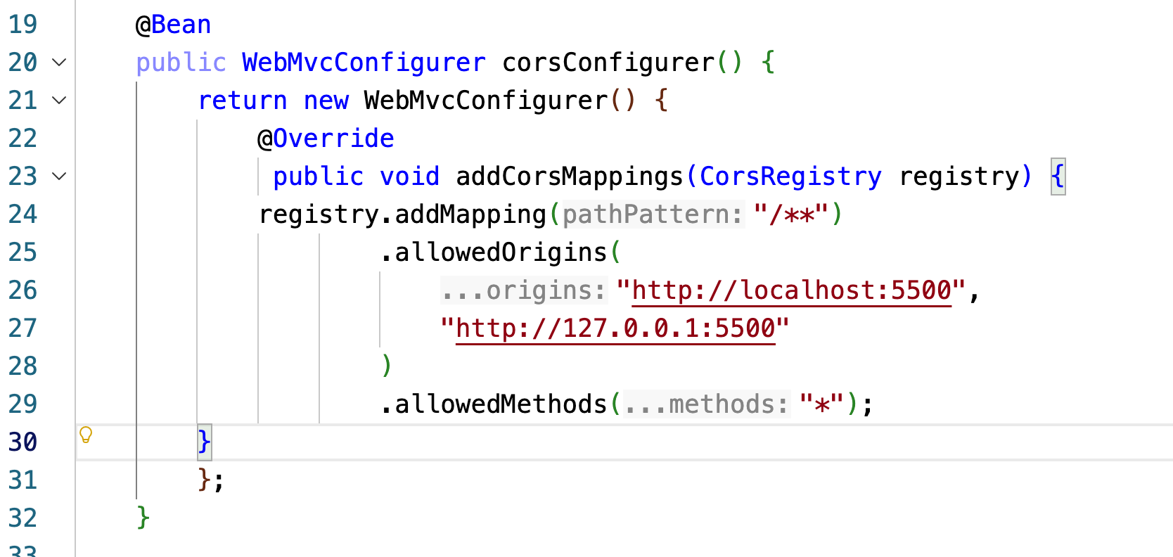
Figure 2. Your front-end (running on localhost:5500) and back-end (spring boot) run on different ports, which makes them have different origins.

Step 4: Navigate to the front-end project and open the file Registration.js. Locate the submitForm function. The current version builds a string and displays it on the page. This is no longer needed because the data will be sent to a back-end. Remove the code that creates and displays formText.

Step 5: Modify the submitForm function so that it can communicate with a back-end server by adding the keyword async before the function definition. This change allows the use of await when sending requests and receiving responses from the server.

Step 6: Create an object that contains the form data. This object will be sent to the server in JSON format and use the fetch function to send a POST request to the backend (see below).
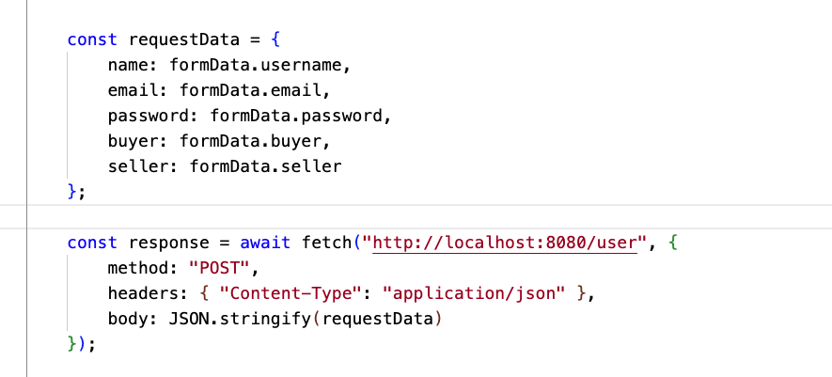
Figure 3. Create a JSON object from the form data and send it to the back-end using a POST request with fetch.

Step 7: After sending the request, add code to check if the response is successful. If it is, display a success message. Otherwise, display a failure message.

Step 8: Run the back-end and start the front-end. Try registering a new user. If things work correctly, you should see the “Registered Successfully” alert as before.

Activity 2: Connecting the Allotment Food-Sharing Spring Boot Backend to the React Frontend (Inside the Activity 2 Folder)

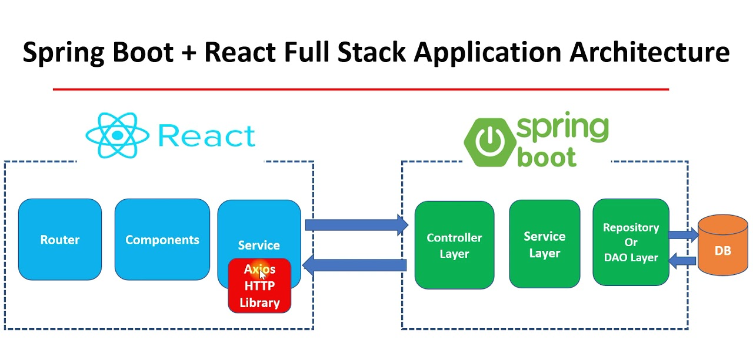
Figure 4. Spring Boot + React full-stack architecture showing front-end components communicating with back-end services and database via HTTP APIs.

Step 1: Inside Backend_SpringBoot, folder and inside DemoApplication.java class. Add the corsConfigurer method as shown in Figure 5. Make sure to import as follows.

Import org.springframework.web.servlet.config.annotation.CorsRegistry;
Import org.springframework.web.servlet.config.annotation.WebMvcConfigurer;

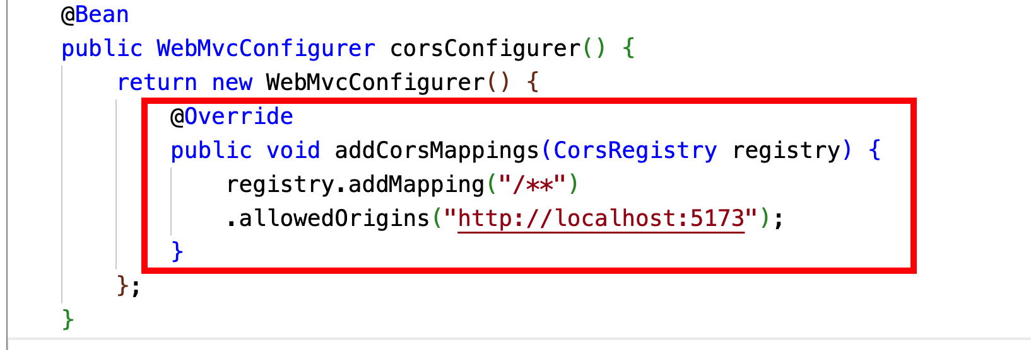
Figure 5: Spring Boot project structure and main application class showing CORS configuration to allow requests from http://localhost:5173.

Step 2: In the Front-end_React, the registration form in the Registration component uses a fake API provider.

Step 3: Change it so that it uses the /user API, which has been created in the backend.

Step 4: For this, you need to modify the code for handleSubmit in Registration.jsx, so that it can make an Axios post request to the ‘http://localhost:8080/user’ endpoint. Refer to Week 9 lecture and lab for information on Axios.

Step 5: Run the backend and start the frontend. Try registering a new user. If things work correctly, you should see the “Registered Successfully” alert as before.

Step 6: The response from the back-end server should also be printed out to the console.

Step 7: You can also use ThunderClient GET /user to check whether the new user is added to the database. If things don’t work as expected, start debugging by looking at the error outputs in the browser using Developer Tools or, at the back-end, look at the console.

Challenge Activity: Add Security to the Front-end (HTML CSS & JavaScript) and Back-end (Spring Boot) integration

In this challenge, you will enhance your full-stack application by adding basic security to both the front-end (HTML, CSS, and JavaScript) and the Spring Boot backend.

- On the front-end, input validation and prevention of invalid form submissions have already been implemented.
- On the back-end, you should implement server-side validation, handle errors appropriately, and restrict access using proper CORS configuration.

FOLLOW UP WITH YOUR START-UP TEAM

This lab extends your full-stack development skills by integrating a front-end with a Spring Boot back-end using REST APIs. You also practise storing and retrieving data through Spring Data and observing how the front-end communicates with the back-end and database. The techniques you learn in this lab will support your coursework CS2802 and help you understand how full-stack systems operate in real-world applications.

References
- Refer to the Weeks 5, 7, 9, 22 and 24 Lectures for the necessary background content.
- Read Part 1, Full Stack Development with Spring Boot 3 and React, by Juha Hinkula, 2023.
- https://vite.dev/guide/
- https://react.dev/learn
- Spring Documentation on Spring Web MVC
- Building REST services with Spring
- https://www.thunderclient.com/
- Chapters 1- 7, Modern JavaScript from The Beginning [Second Edition] by Brad Traversy, 2023
- https://www.w3schools.com/

Appendix: React vs HTML/CSS/JS – Quick Comparison
Aspect | React | HTML / CSS / JS
HTTP requests | Axios and useFetchData() | fetch() in a plain event listener
Form handling | useState + onChange handlers | document.getElementById() + event listeners
Displaying results | JSX state update (setData) | document.getElementById().textContent = ...
Loading / error state | useState booleans in component | Inline DOM updates before and after fetch
Setup required | npm install, Vite build step | Go Live on VS Code
CORS origin (dev) | http://localhost:5173 (Vite) | http://127.0.0.1:5500 (Live Server)

